*From here the user will enter the item they wish to maintain, create or List. The number is checked against the* **ItemMaster.ItemNo** table to determine if it exists. If it does not exist then a Y/N pop-up message displays stating that the item does not exist, do they want to create it?

* Reminder when adding a new item, it cannot be a duplicate and must be checked against the InventoryMaster.itemNo table. If the item already exists, return the item number value to the item selection and display message.”Item already exists. Please try again.”

If a List is requested using the filters then Screen 02 is displayed and the user can choose an item from the list to maintain.

**Question? Should we allow the copy function from here?**

**List Function**

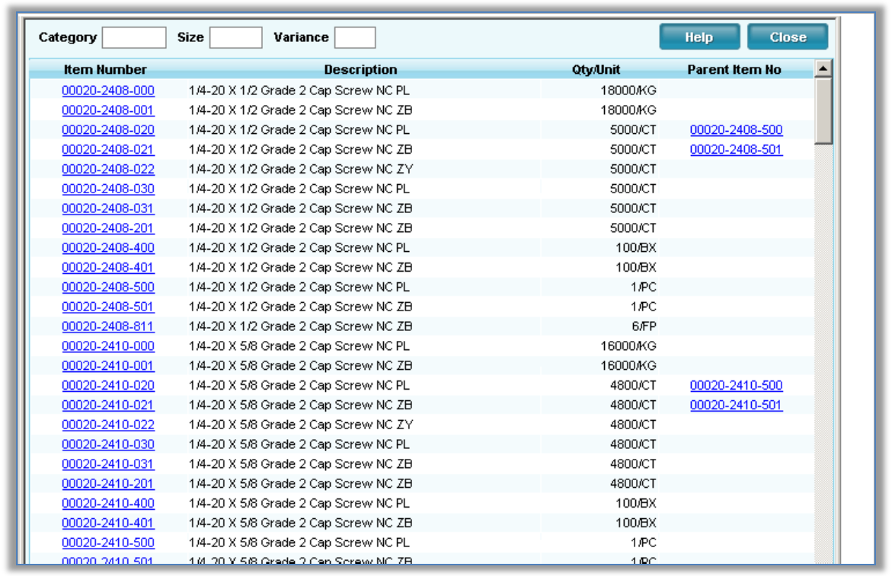

Screen 02- The user can use this screen over and over until they click on the item they want to maintain or review.

***TMD - Is this an existing screen?***

***Developer notes:***

1. Store the **pItemID** that is returned from a valid item selected, it will be used throughout the session.
2. **Item Number** – Format 00000-0000-000. When a new item number is written to the database is should use a generic insert statement, it is then recalled from the database using the generic select statement in order to populate the screen with any defaults imbedded in the database.
3. **Category No. –** Cannot be changed once a item is created – during the copy function this field is to be prompted for the newly establish the category number (if needed) the new category should be selected from the category drop down - Allow for change only on a new or copied item**.** Once the category is set gray it out – allow the user to finish the next two field thus creating a new item number. If it is a new item and not a copy then write the item to the Item master table a retrieve the defaulted base columns and display them – if it is a copy then test the item number for duplicates and write the data as displayed – copy the UM table and pint the copied UM items to the new Item master internal id and item number. - some of the data can be over laid as the user changes items on the screen

**TMD – Do we need a button for the new item to go and return the defaults?**

1. **Size Description –** If thesize is changed by the user, clear the text box and allow for entry.
2. **Category Description –** If the Category is changed by the user, clear the text box and replace data with the relevant category description from the Category list.
3. **Description –** Populate only when **Build Description** or **Save is clicked** by merging Size, Cat & Plate.
4. **Alt Description & Size –** Do not move from copied item but allow for user entry.
5. **Customer No –** Do not move from copied item. Populate ddl with CustNo - CustName
6. **UPC Code –** Do not move from copied item. See Bruce #7 for UPC rules
7. **Vendor No –** Do not move from copied item but allow for user entry.
8. **Vendor Item No –** Do not move from copied item but allow for user entry.
9. **Routing No –** Do not move from copied item but allow for user entry.
10. **Production BOM No –** Do not move from copied item but allow for user entry. Validate against the BOM table.
11. **Flushing Method –** Bring over from copied Item data but do not make available to user for change.
12. **Corp fixed Velocity -** Do not move from copied item but allow for user entry.
13. **PPI Code -** Do not move from copied item but allow for user entry.
14. **Harmonizing Code –** Do not move from copied item but allow for user entry.

**TMD – Move data from original copied item & allow changes except as noted**

**Buttons**

1. **Close** – Exit screen, clear any session variables when data is not present. If data is present
   1. **If this was a new item or cloned item in this session and the user wants to leave the screen using ‘Close’ then prompt the user and let them know they are leaving the screen without saving the newly created item** – If they choose to continue then physically delete the newly created item and UM records.
2. **Delete** – Display message: “Do you want to delete this Item?'

**Y**- Set DeleteDt and DeleteUserID(new field) and clear all fields, variables and refresh screen

**N**- Close message, continue session

1. **Save –**

**Grid View - ???**

**Entry Area –** Save data and build description by merging Size, Category &Plating if field is blank.

1. **Build Description –** Merge Size Description, Category Description and Plating.
2. **Package –** build PKG UPC Code (See Bruce notes #7)
3. **Bulk -** build Bulk UPC Code (See Bruce notes #7)

* **Item Details**

The grid has multiple views and is controlled by ***InvItemDetails***. The grid view changes as the user chooses a different selection from the drop down.

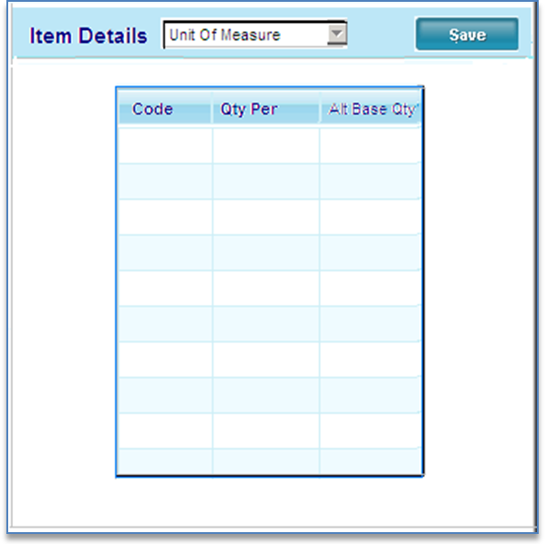

Screen 05

* **Unit of Measure (ItemUM table)**

UOM data should be brought over from copied item and available for any necessary modifications.

1. **Code –** Bring Over from copied item
2. **Qty Per –** Bring Over from copied item
3. **Alt Base Qty –** Bring Over from copied item

***Side Menu:***

This is the side menu for the Item Maintenance screen.

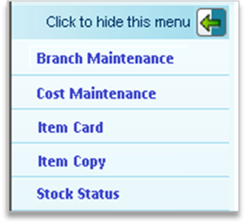

**Add:**

* Item SKU Analysis (existing function)
* Branch Stocking Analysis (existing function – might need modification)
* Item Notes (set as ‘Under Construction’)
* CPR (Existing function – designed to run from Stock Status)
* Item Builder (Existing Function – that runs from Stock Status)

|  |  |  |  |  |  |  |
| --- | --- | --- | --- | --- | --- | --- |
| **ItemMaster** | |  | |  |  |  |
| **Screen Element** | **Column** | | | **Dependencies** | **Defaults** | **Events** |
| **n/a** | pItemMasterID | | numeric(9,0) | Identity column |  |  |
| **Item Number** | ItemNo | | varchar(20), | Can not be duplicated | none |  |
|  | AltItemNo | | varchar(20), | Can not be duplicated |  |  |
| **Parent Item** | ParentProdNo | | varchar(40), |  |  |  |
| **Description** | ItemDesc | | varchar(50), | Entered field |  |  |
|  | ItemStat | | char(2) | Drop down |  |  |
|  | RecTrans | | char(2) | Y or N Default Y |  |  |
|  | Specification | | varchar(255) | Enterable |  |  |
|  | Tariff | | varchar(20), | Enterable |  |  |
| **Category Description** | CatDesc | | varchar(80), | Generate from Category  GroupDescription table |  |  |
| **Plating** | Finish | | char(4), | Generate from CatelogPlating table |  |  |
| **Size Description** | ItemSize | | varchar(30), |  |  |  |
|  | PriceCat | | varchar(10), |  |  |  |
|  | PcsPerPallet | | float | Calculated (same as Sup/Eqv qty |  |  |
|  | DensityFactor | | numeric(9,0) |  |  |  |
|  | GLPostingTbl | | numeric(9,0) |  |  |  |
| **Base UOM** | SellStkUM | | char(5) | Use list |  |  |
|  | SellStkUMQty | | float |  |  |  |
| **Pur UOM** | CostPurUM | | char(5), | Use list |  |  |
| **Sell UOM** | PriceUM | | char(5) | Use list |  |  |
| **SuperUM** | SuperUM | | varchar(5) | Use list |  |  |
| **Sell UOM** | SellUM | | varchar(5) | Set to Price UM |  |  |
|  | SleeveUM | | varchar(5) |  |  |  |
|  | DensityUM | | char(5) |  |  |  |
|  | StkUM | | varchar(5) |  |  |  |
|  | Height | | float |  |  |  |
|  | Width | | float |  |  |  |
|  | Depth | | float |  |  |  |
|  | CubicMsr | | float |  |  |  |
| **Net Weight** | Wght | | float | Entered by user | 3 dec |  |
| **Gross Weight** | GrossWght | | float | Net weight + routing weight  = Gross Weight | 3 dec |  |
|  | PUMGrossWght | | float |  |  |  |
|  | PUMNetWght | | float |  |  |  |
| **Weight 100** | HundredWght | | float | Weight/SellStkQty * 100 |  |  |
|  | TariffCd | | char(4) |  |  |  |

|  |  |  |  |  |  |  |
| --- | --- | --- | --- | --- | --- | --- |
| **ItemMaster (cont)** | |  | |  |  |  |
| **Screen Element** | **Column** | | | **Dependencies** | **Defaults** | **Events** |
| **UPC Code** | UPCCd | | varchar(12), | Developed from the PKG or Bulk UPC table find the first open row (PFC item number is blank) |  |  |
|  | CommodityCd | | varchar(8), |  |  |  |
|  | SerialNoCd | | char(2) |  |  |  |
|  | FormatCd | | char(2) |  |  |  |
|  | TaxStatCd | | char(2) |  |  |  |
|  | PieceCstCd | | varchar(10) |  |  |  |
|  | AuditCostInd | | char(1) |  |  |  |
| **Haz Mat** | HazMatInd | | char(1) |  |  |  |
|  | DetPartsInd | | char(1) |  |  |  |
| **Web Enabled** | WebEnabledInd | | char(1) |  |  |  |
|  | CostMarkupAdder | | char(4) |  |  |  |
| **Corp Fixed Velocity** | CorpFixedVelocity | | varchar(10) | Enterable |  |  |
| **Delete Date** | DeleteDt | | datetime | Display only |  |  |
| **Entry date** | EntryDt | | datetime | Display only |  |  |
| **Entry Id** | EntryID | | varchar(50) | Display only |  |  |
| **Change date** | ChangeDt | | datetime | Display only |  |  |
| **Change id** | ChangeID | | varchar(50) | Display only |  |  |
|  | StatusCd | | char(2) |  |  |  |
| **Pallet Partner** | PalPtnrInd | | char(1) | Enterable |  |  |
|  | ReplacementCost | | money |  |  |  |
|  | ReplacementCostAlt | | money |  |  |  |
|  | VelocityCd | | varchar(10) |  |  |  |
|  | IMHealth | | varchar(5) |  |  |  |
|  | CatVelocityCd | | char(3) |  |  |  |
| **Turn Ranking Code** | Ranking | | bigint | Display |  |  |
|  | ListPrice | | money |  |  |  |
| **Costing Method** | CostMethod | | char(2) | Display only |  |  |
|  | CommissionSchd | | char(4), |  |  |  |
|  | PackageGroup | | varchar(10), |  |  |  |
|  | BuyGroup | | int |  |  |  |
|  | BuyGroupDescription | | varchar(80), |  |  |  |
|  | ProductLine | | int |  |  |  |
|  | ProductLineDescription | | varchar(80), |  |  |  |
|  | ProductLineSort | | int |  |  |  |
|  | ItemPriceGroup | | varchar(20), |  |  |  |
|  | CertRequiredInd | | char(2), |  |  |  |
| **PPI** | PPICode | | varchar(30), |  |  |  |
|  | QualityInd | | char(2), |  |  |  |
| **Low Profile Pallet Qty** | LowProfilePalletQty | | float | NOT USED |  |  |
| **Diameter** | DiameterDesc | | varchar(15), | Enterable |  |  |
| **Length** | LengthDesc | | varchar(15), | Enterable |  |  |

|  |  |  |  |  |  |  |
| --- | --- | --- | --- | --- | --- | --- |
| **ItemMaster (cont)** | |  | |  |  |  |
| **Screen Element** | **Column** | | | **Dependencies** | **Defaults** | **Events** |
|  | PackageVelocityCd | | Char(1) |  |  |  |
|  | ExcludeFromMRP | | Char(2) |  |  |  |
|  | BoxSize | | Varchar(10) |  |  |  |
|  | PurchaseAltMultiplier | | Numeric(6) |  |  |  |
|  | SalesAltMultiplier | | Numeric(6) |  |  |  |
|  | SubItemInd | | Char(2) |  |  |  |
|  | SellOutItemInd | | Char(2) |  |  |  |
|  | CategoryDescAlt1 | | Varchar(40) |  |  |  |
|  | CategoryDescAlt2 | | Varchar(40) |  |  |  |
|  | CategoryDescAlt3 | | Varchar(40) |  |  |  |
|  | SizeDescAlt1 | | Varchar(40) |  |  |  |
|  | HTIBidPricePerM | | Decimal(18,6) |  |  |  |

**Add UserDeleteID to ItemMaster**

***Use Vendor Selection screen when >1 records to display***

|  |  |  |  |  |  |
| --- | --- | --- | --- | --- | --- |
| **Stored Procedures** | |  |  |  |  |
| **Procedure Name** | **Description** | | **Parameters and Formulas** | | |
| **pIMValidateItem** | Validate Item against the InventoryMaster table using the new item number entered by the user. Check for duplicates. | |  | | |
| **pIMGetCopyItem** | Retrieve all necessary copied item data. | |  | | |
|  |  | |  | | |
|  |  | |  | | |